PA4 Report

Chart:

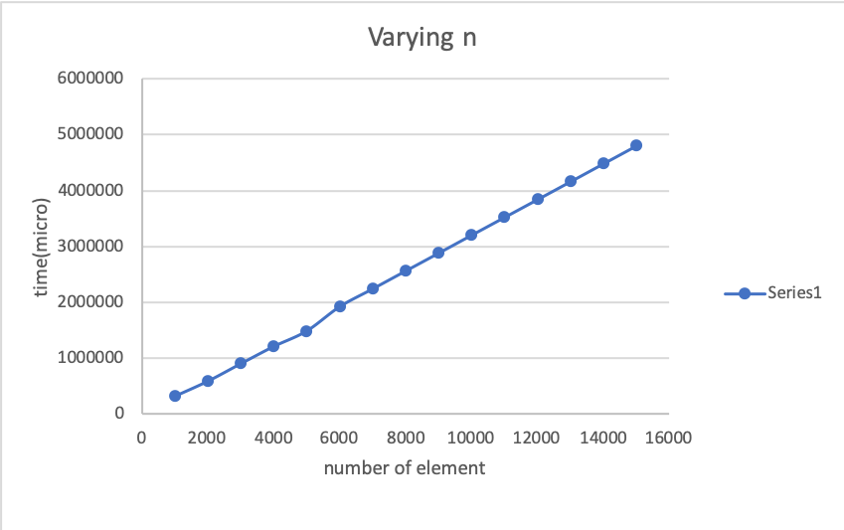

**Explanation:**

**This is pretty straight forward, since we are getting more data point it is obvious it will spend more time.**

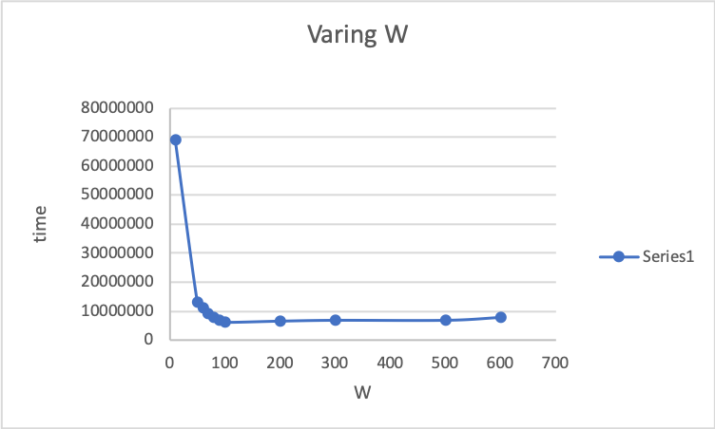

**Explanation:**

**Worker thread has much more workload compare to patient thread, so when we have multiples of them it will increase the performance of the program. But when we have too many of them , many worker thread will stay idle, which might event hurt the performance**

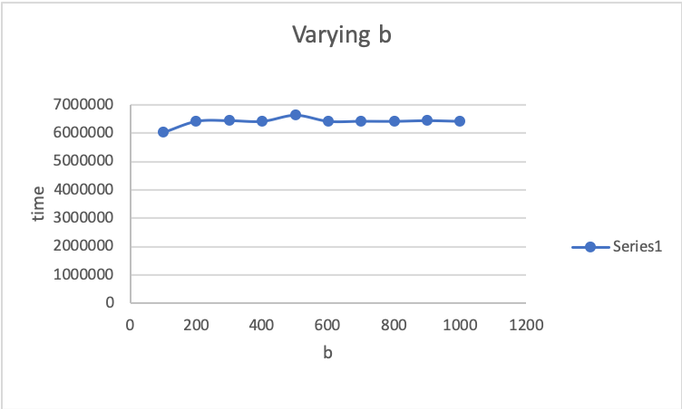

Explanation:

B has not much effect on the performance.

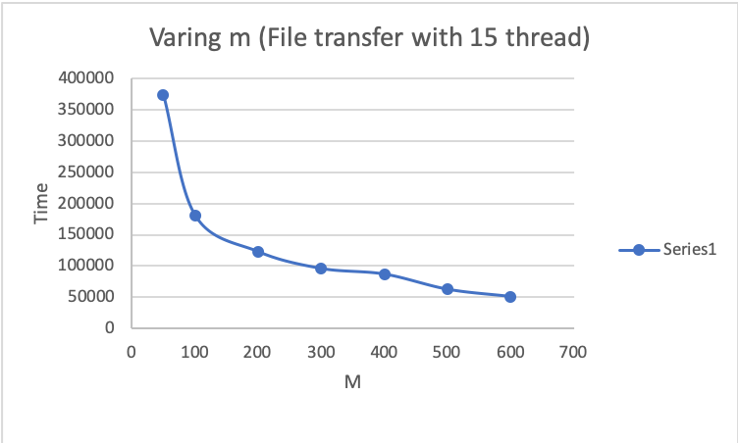

**Explanation:**

**We Already know from PA2 that increase in m will result in less communication between the client and server so it will save time.**

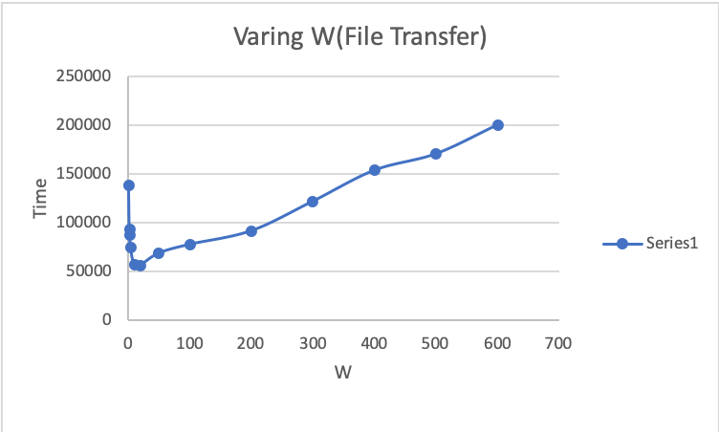

Explanation: The workload of the entire process is not much, so too many thread will hurt the performance(Thread competing with each other.)